**Spring Data JPA with Hibernate Part-1**

**Date 11/03/2021**

**Goolge doc Link:** [**https://docs.google.com/document/d/1wHyNhkUQQ5keSwmVXXvBiyVaw1rHEgxd97gxhDaBBjQ/edit?usp=sharing**](https://docs.google.com/document/d/1wHyNhkUQQ5keSwmVXXvBiyVaw1rHEgxd97gxhDaBBjQ/edit?usp=sharing)

**(1) Create an Employee Entity which contains following fields**

**Name**

**Id**

**Age**

**Location**

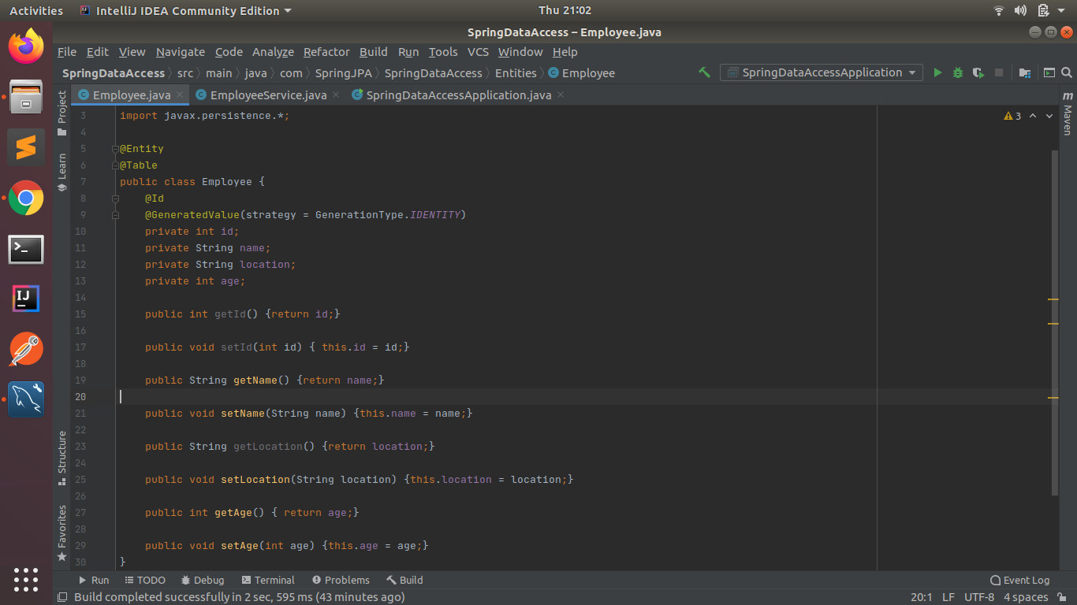

**(2) Set up EmployeeRepository with Spring Data JPA**

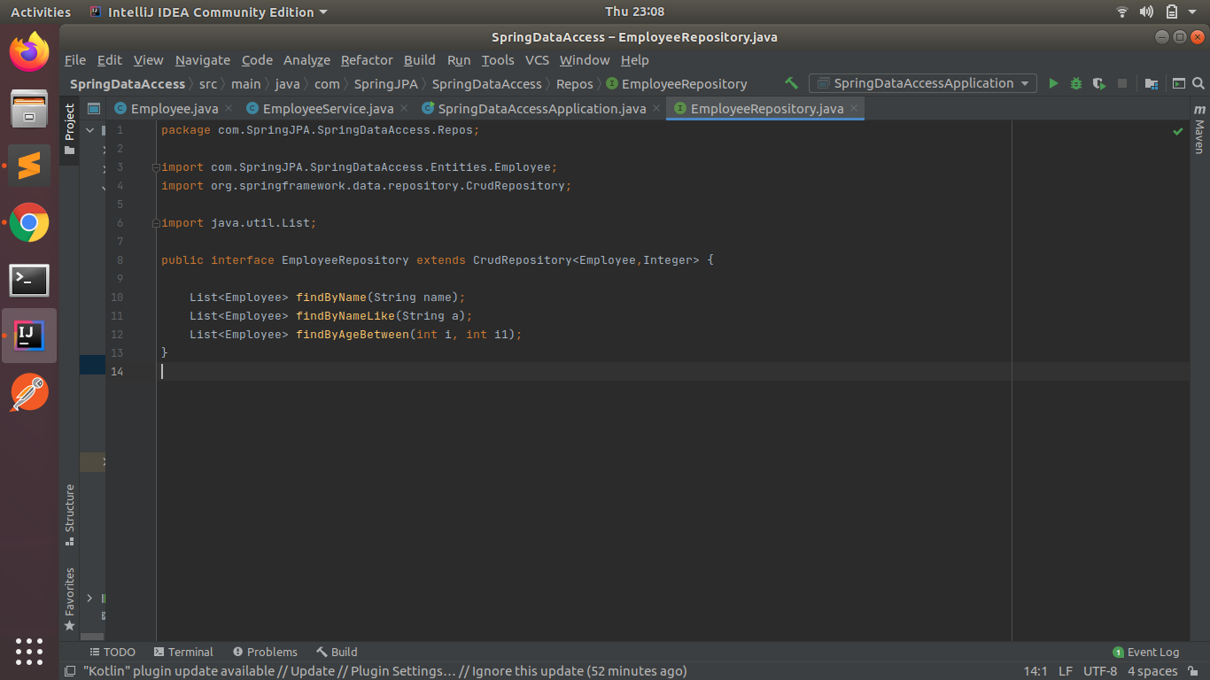

**(3) Perform Create Operation on Entity using Spring Data JPA**

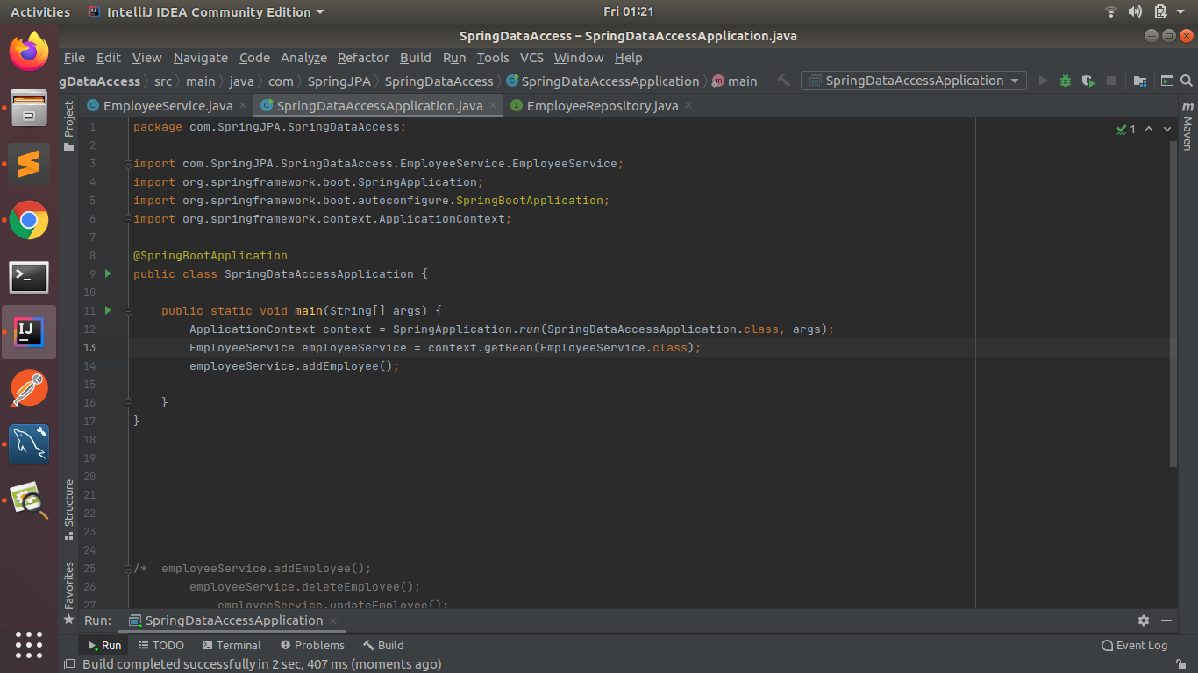

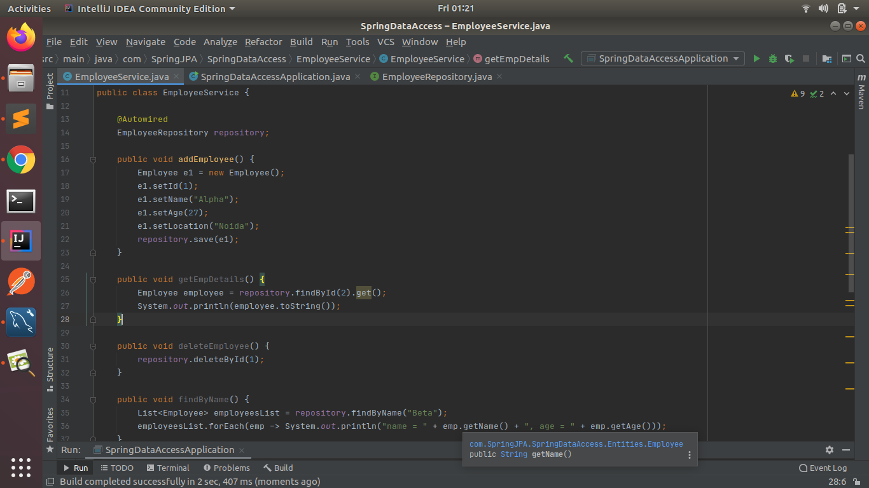

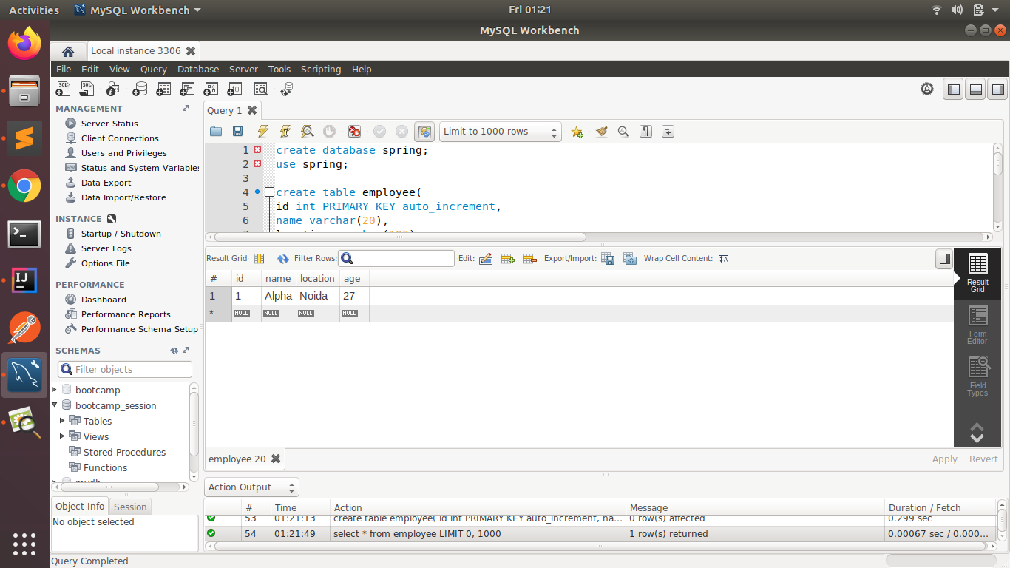

**(4) Perform Update Operation on Entity using Spring Data JPA**

**Before Update:**

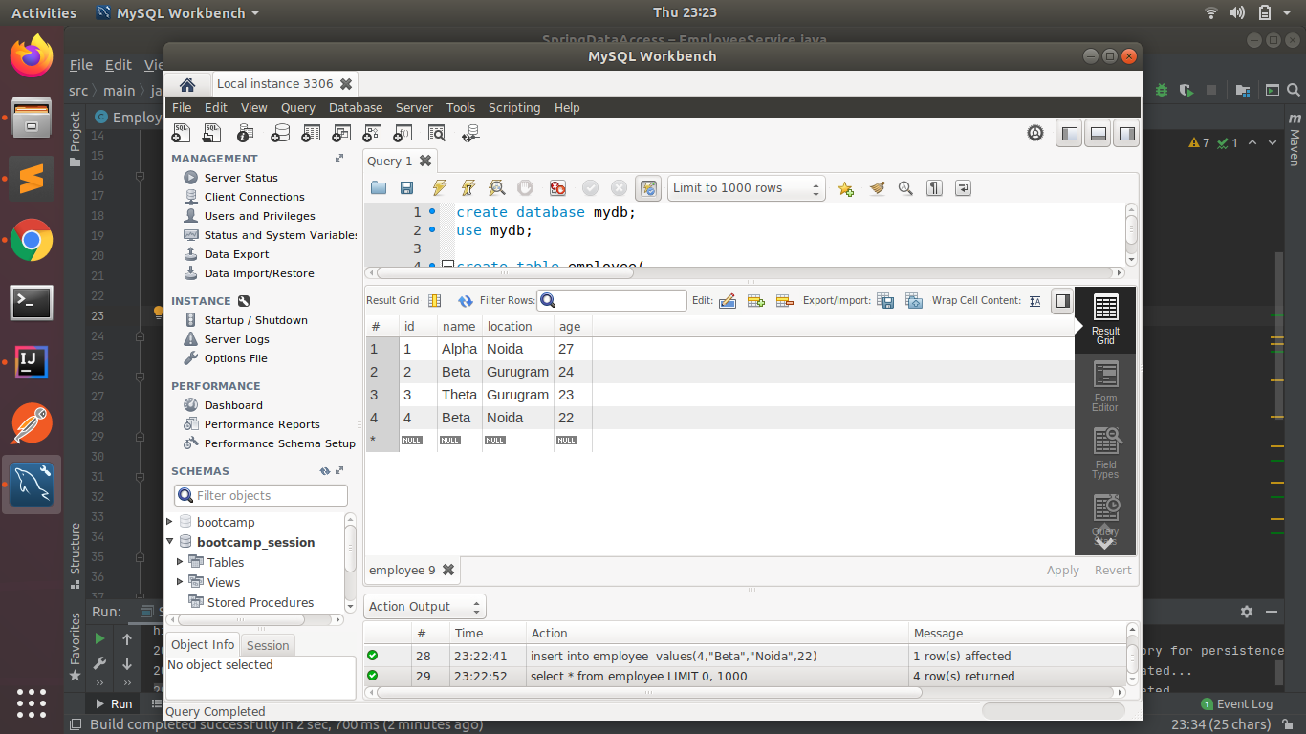

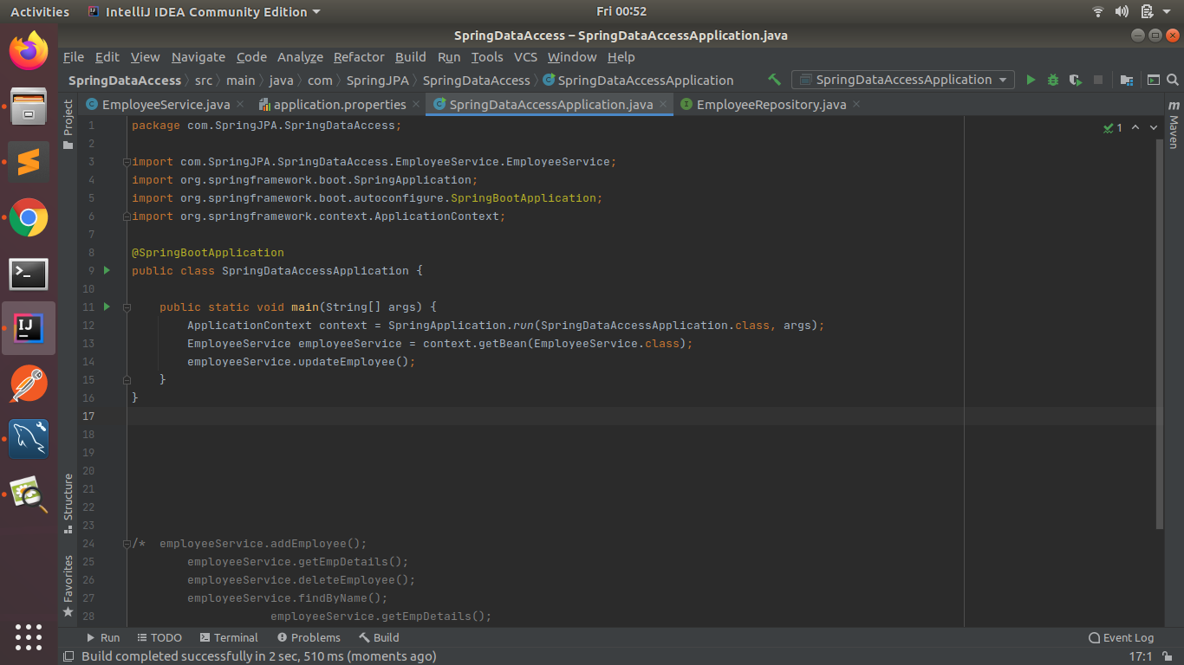

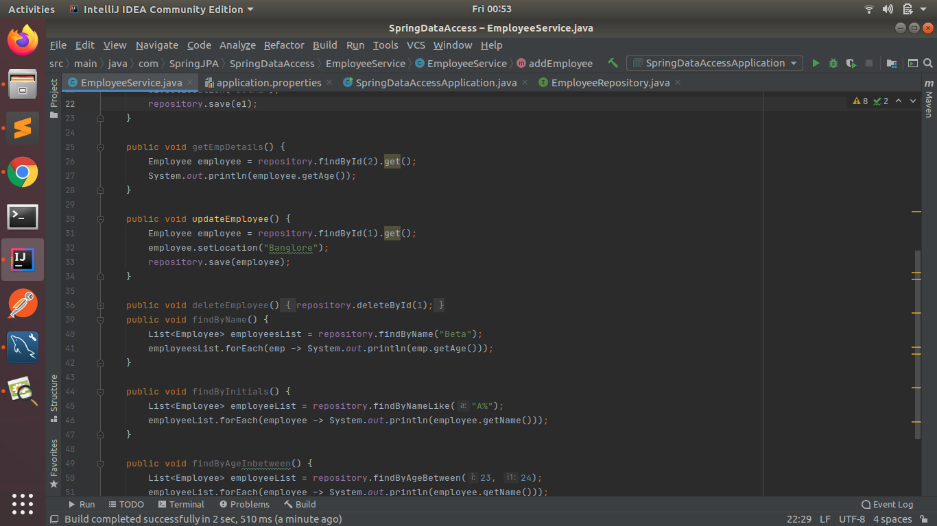

**After Update:**

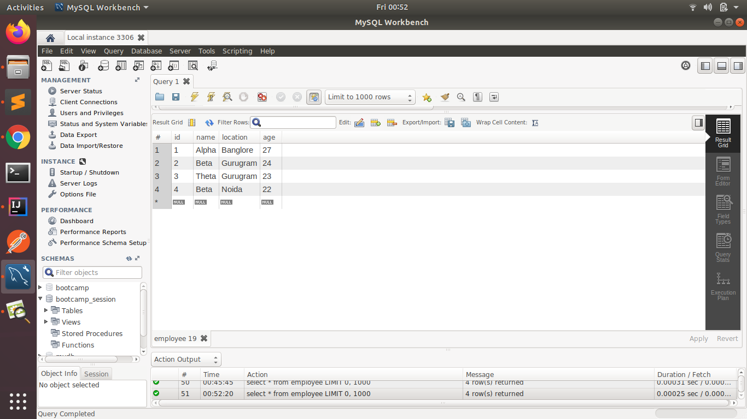

**(5) Perform Delete Operation on Entity using Spring Data JPA**

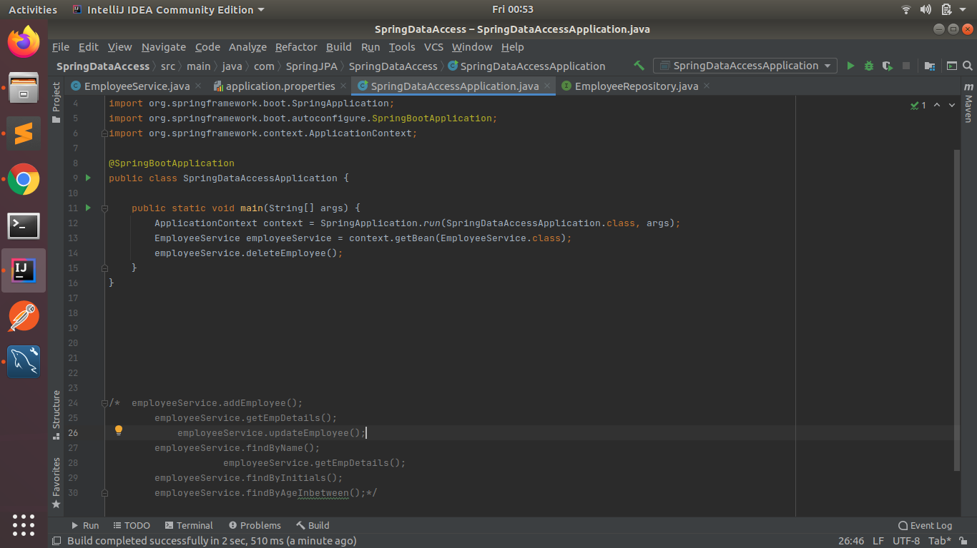

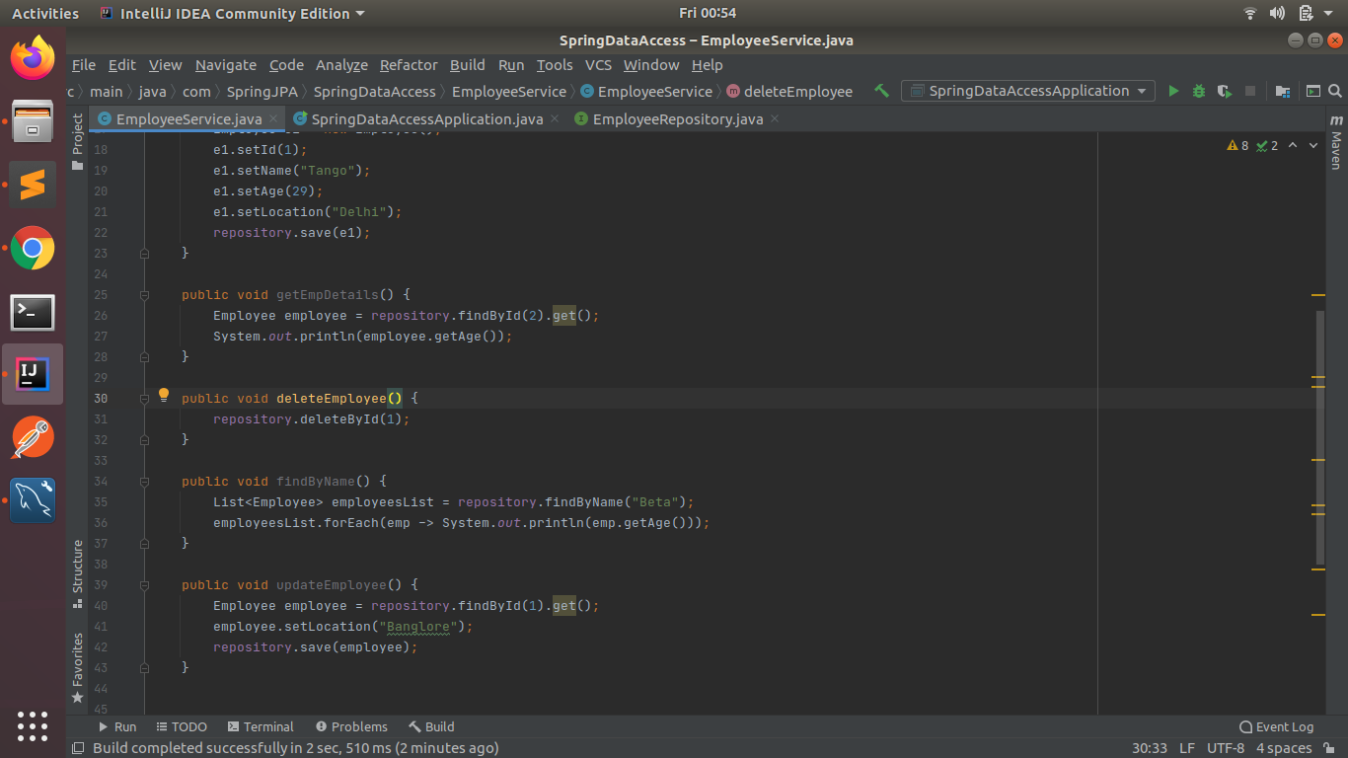

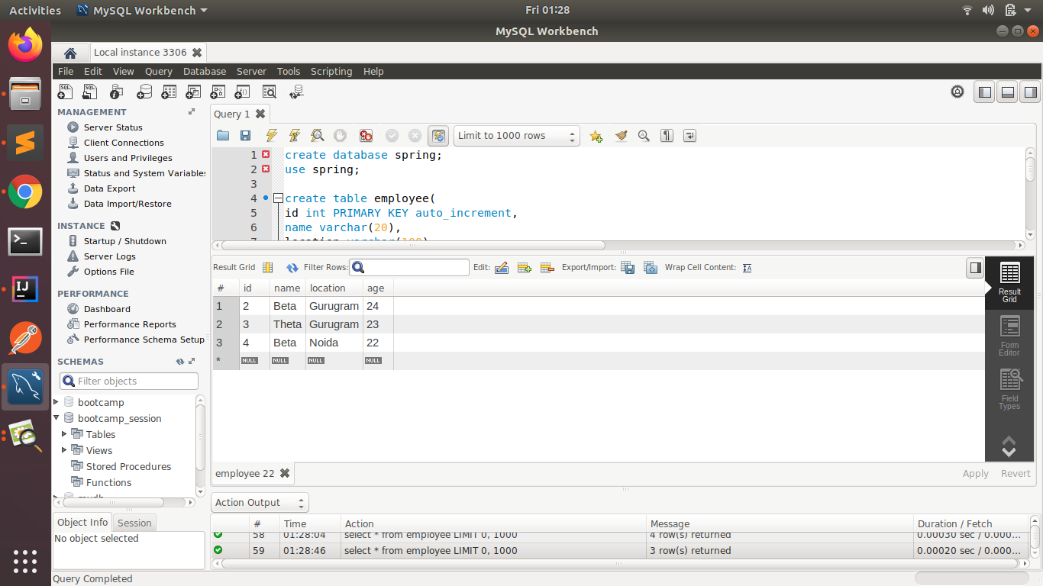

**(5) Perform Read Operation on Entity using Spring Data JPA**

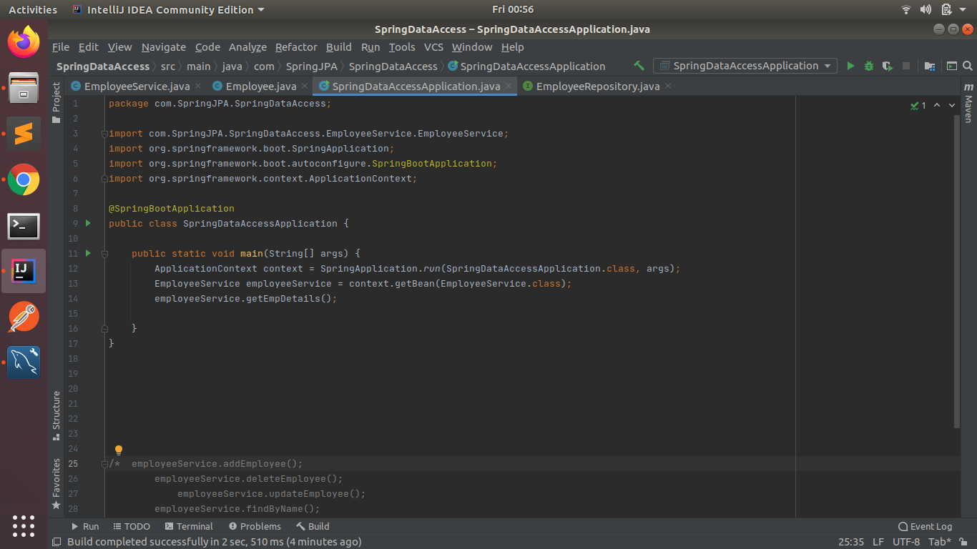

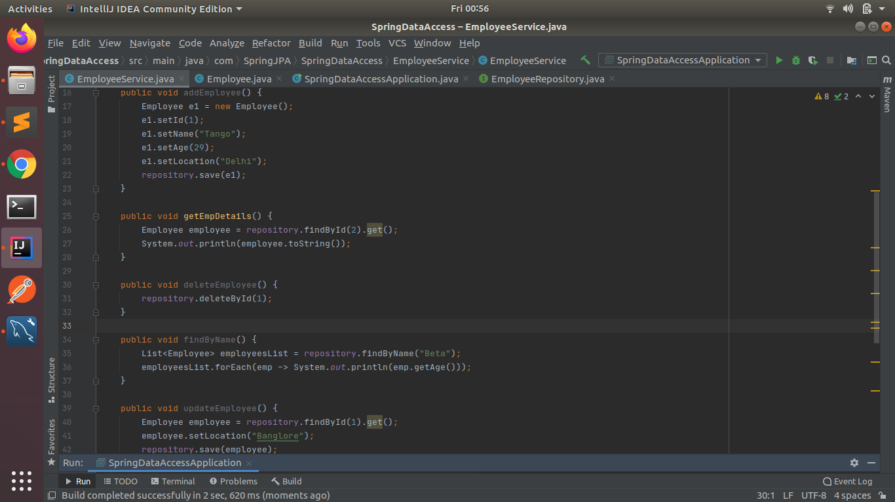

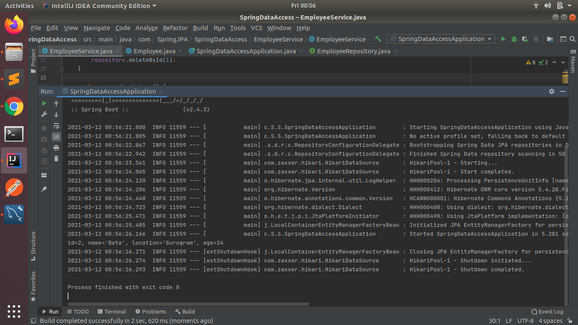

**(6) Get the total count of the number of Employees**

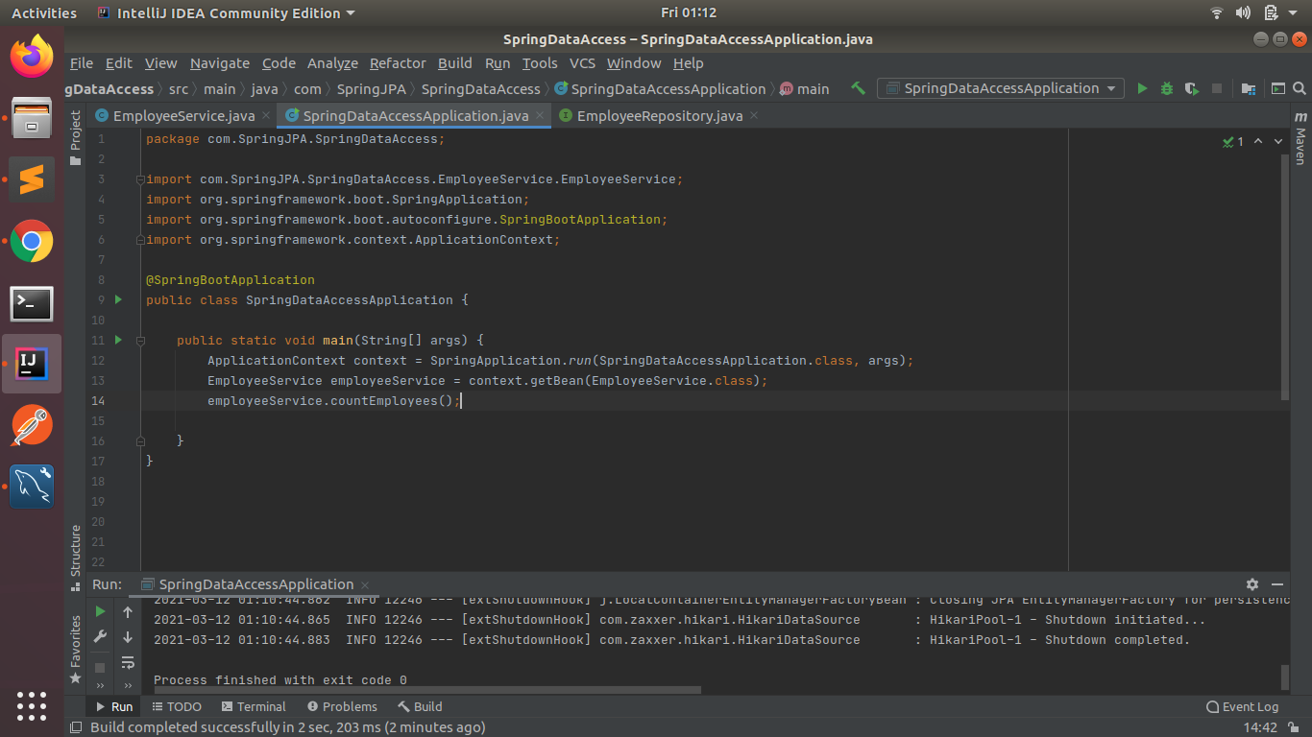

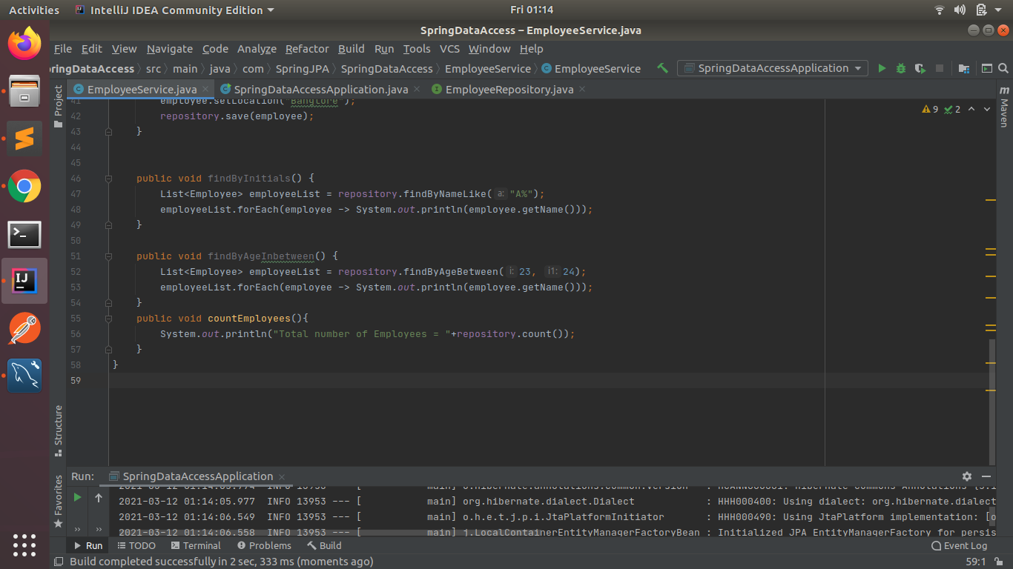

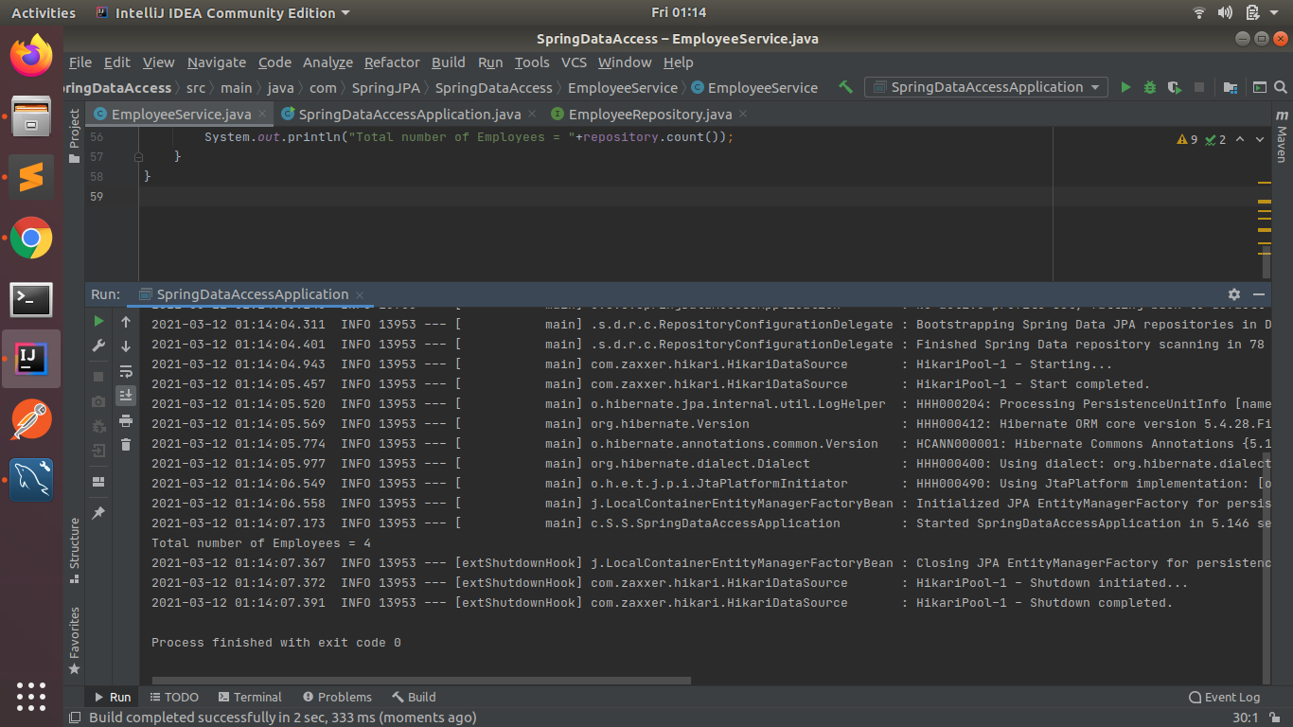

**(7) Implement Pagination and Sorting on the bases of Employee Age**

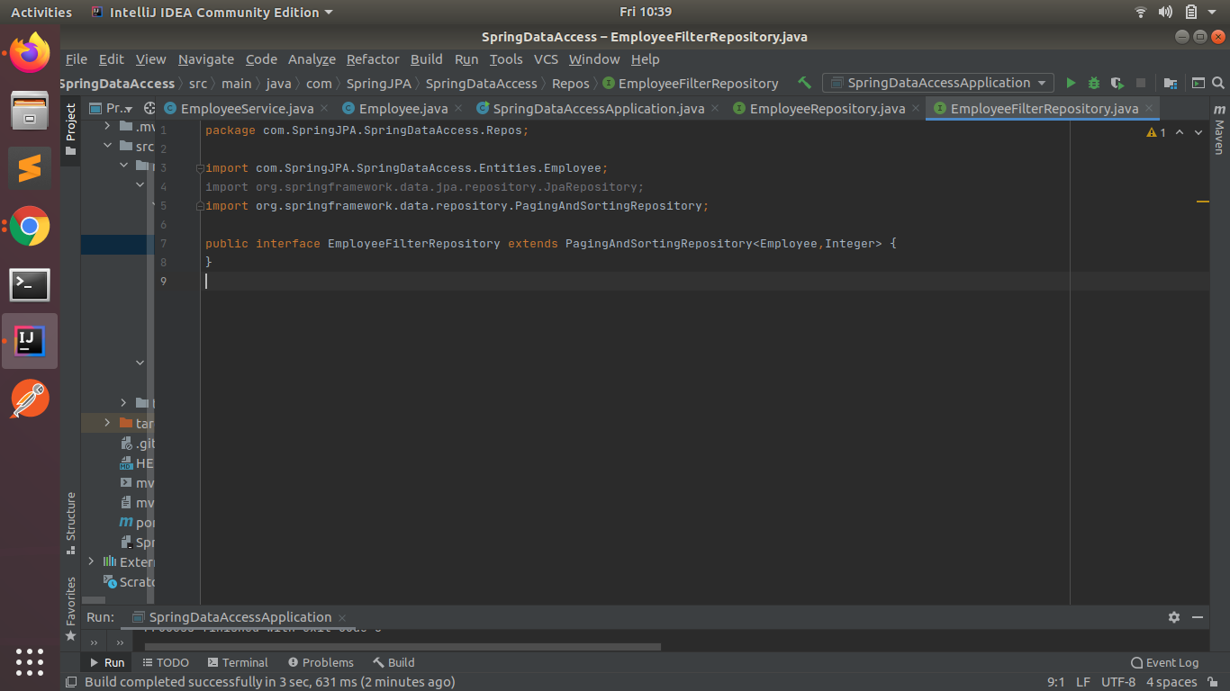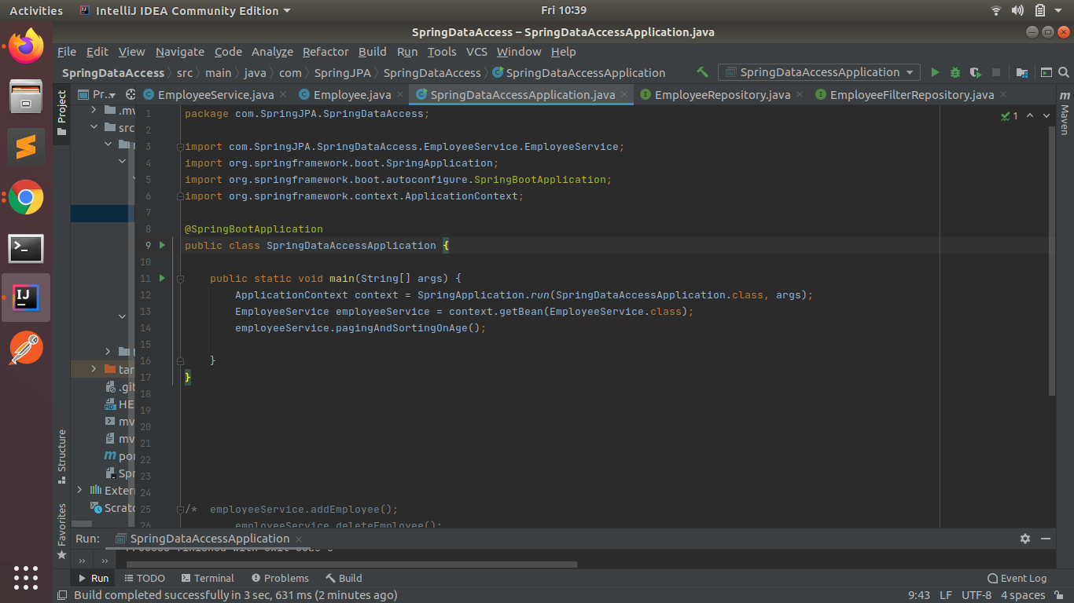

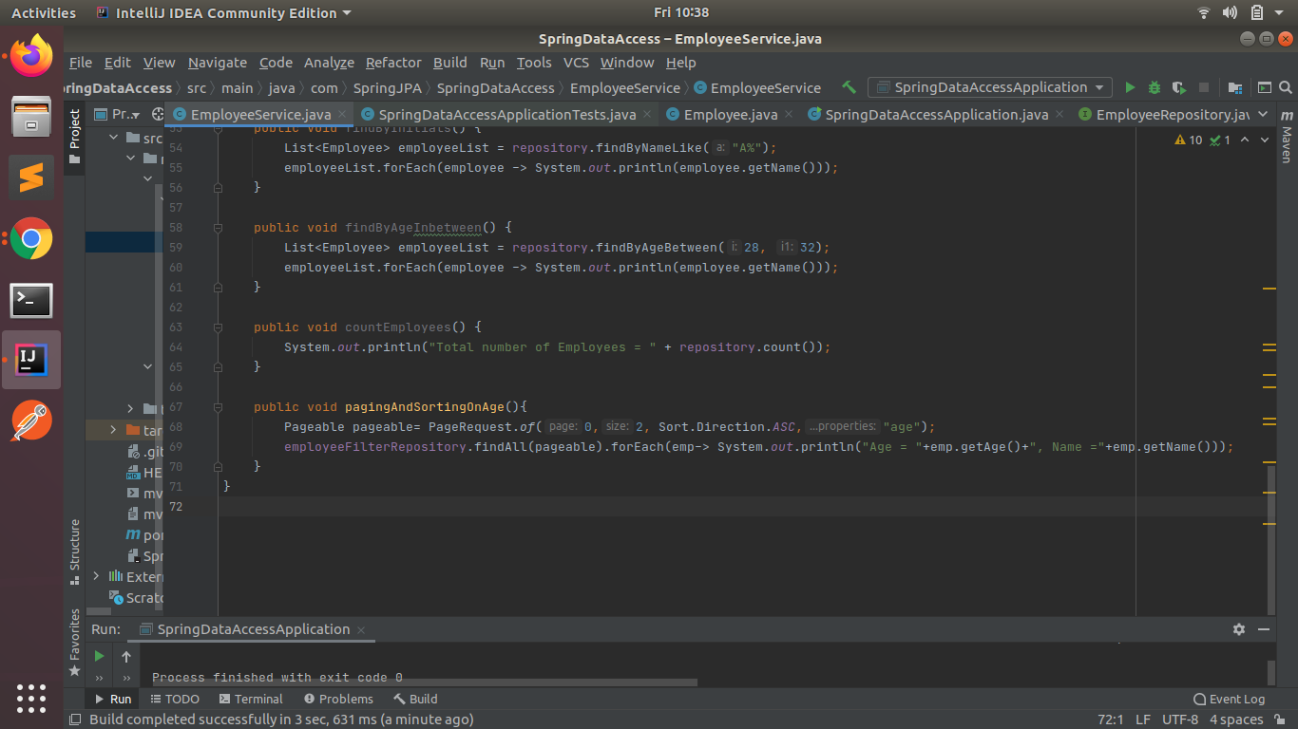

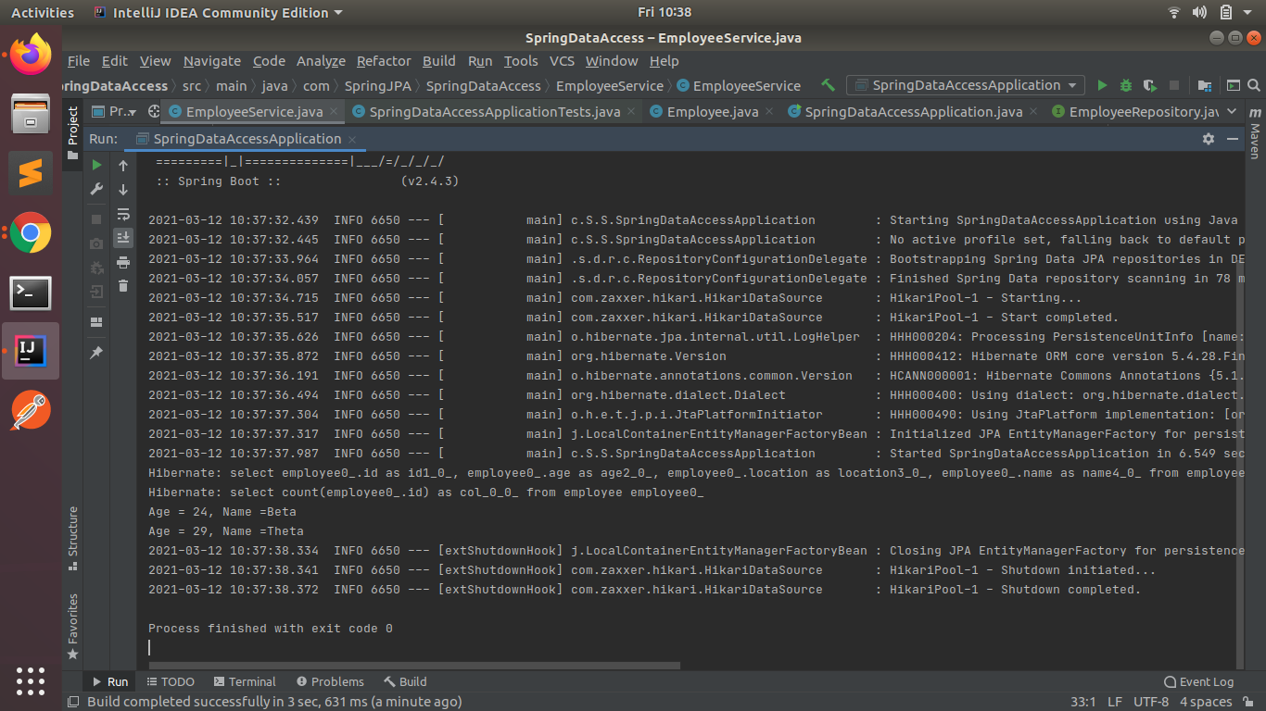

**(8) Create and use finder to find Employee by Name**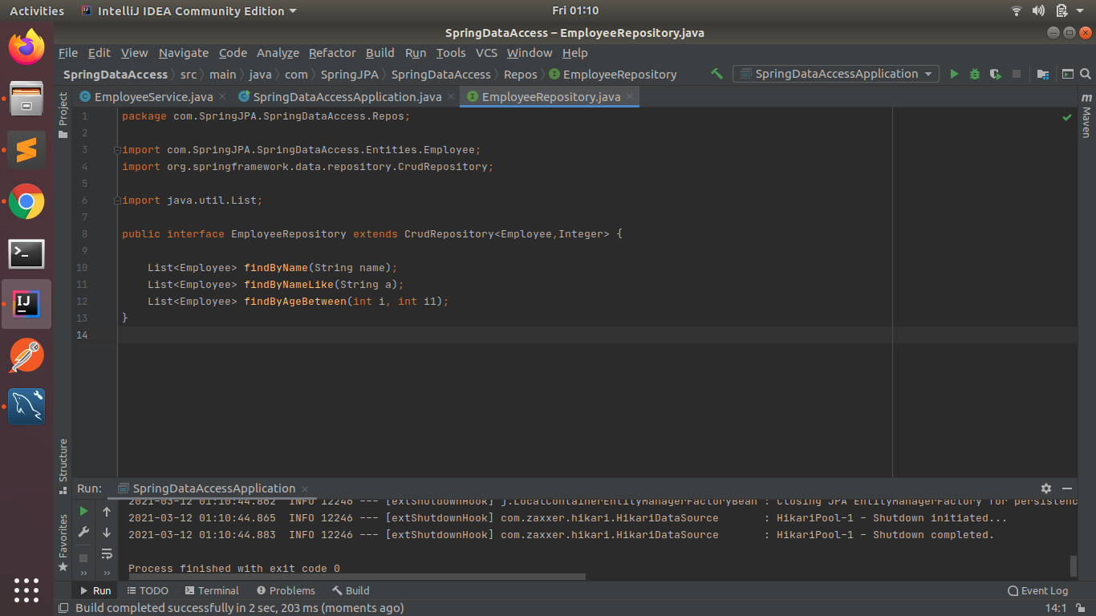

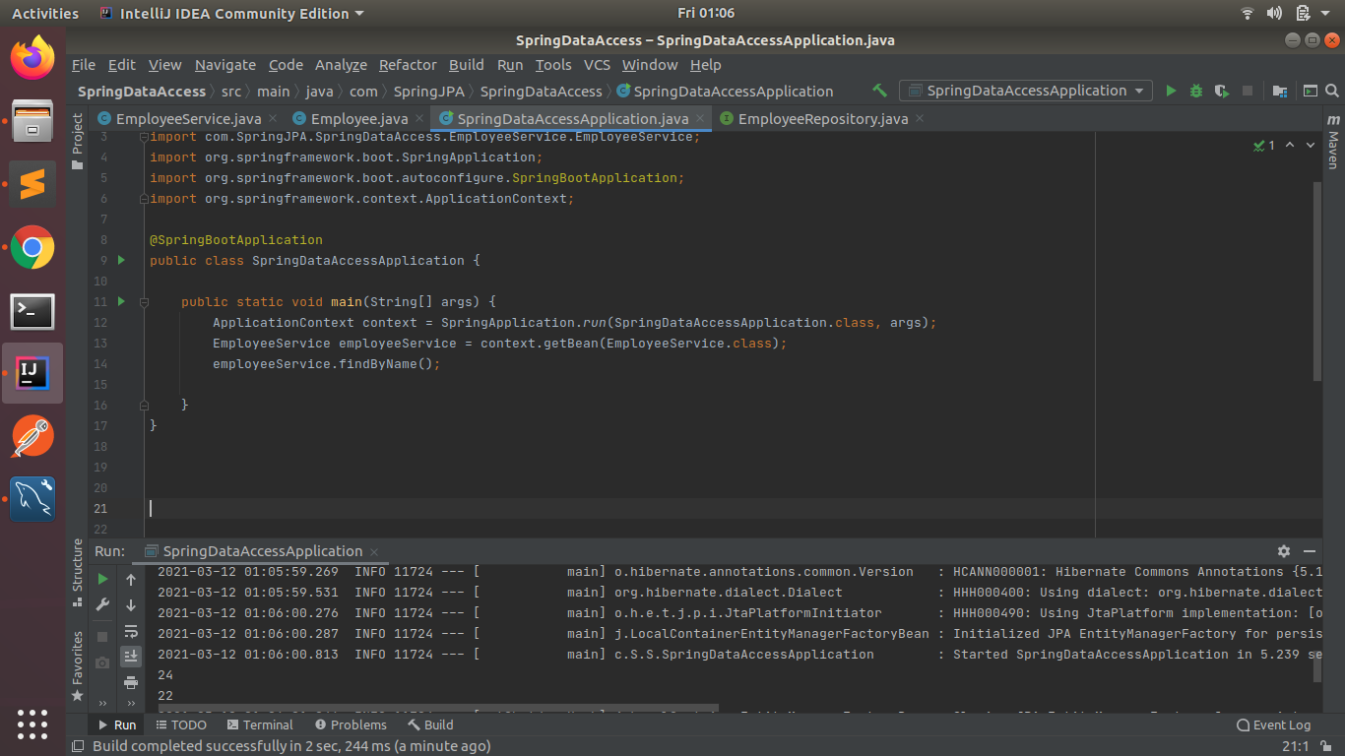

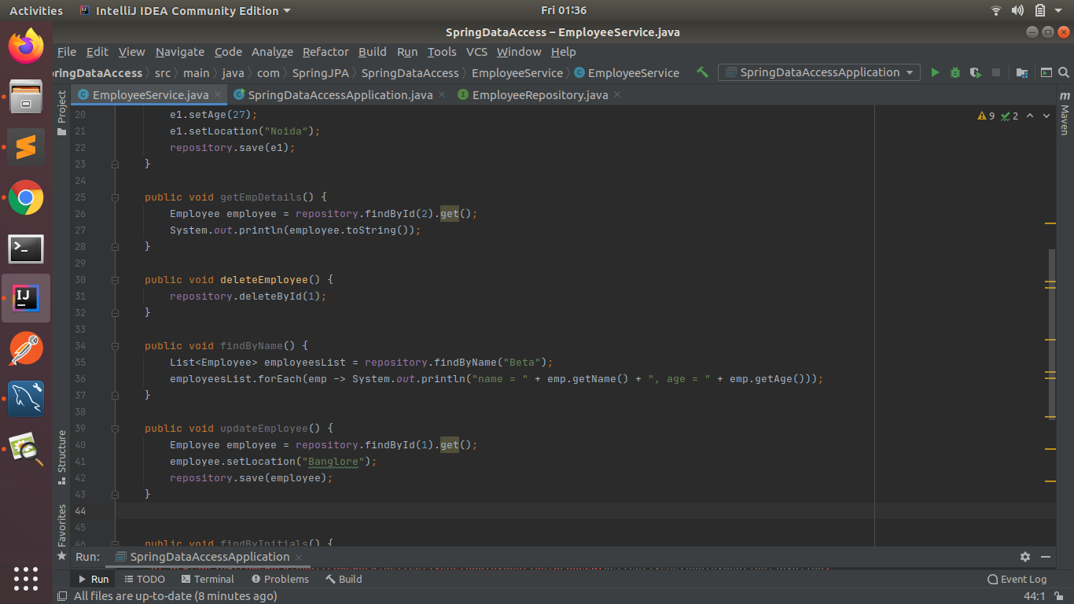

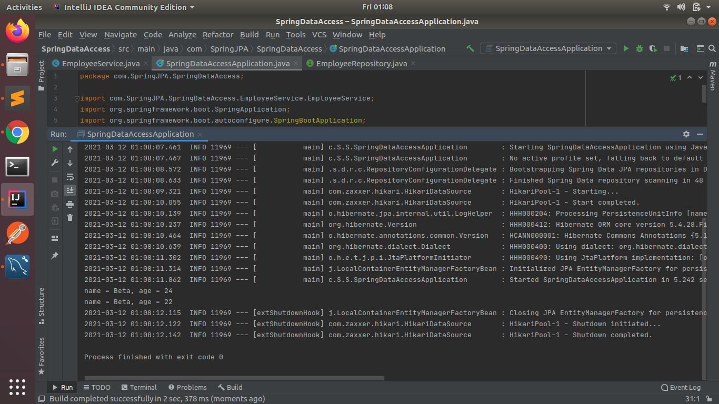

**(9) Create and use finder to find Employees starting with A character**



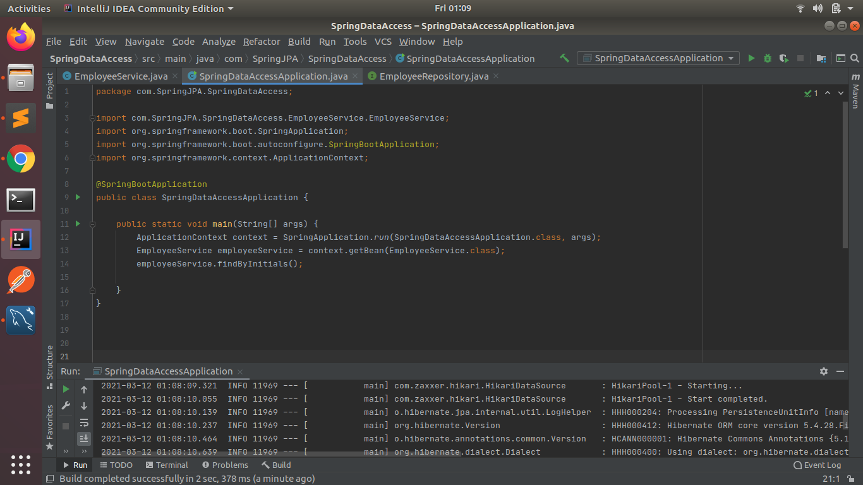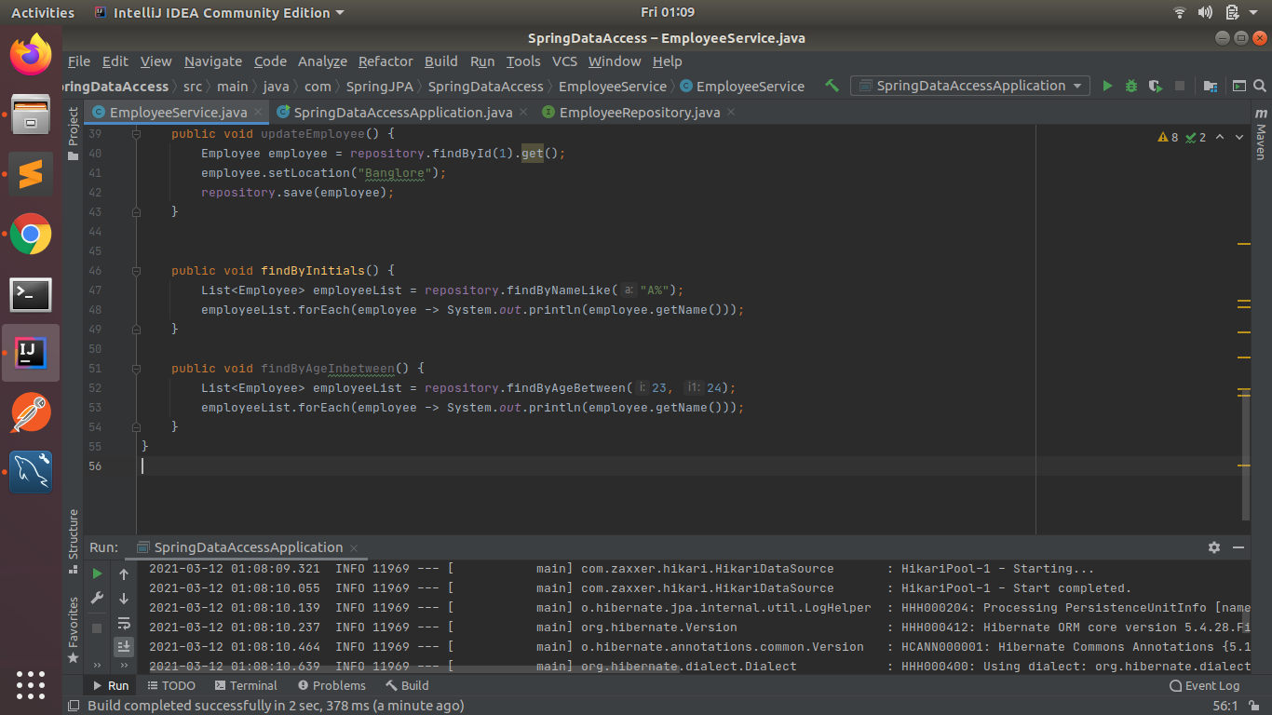

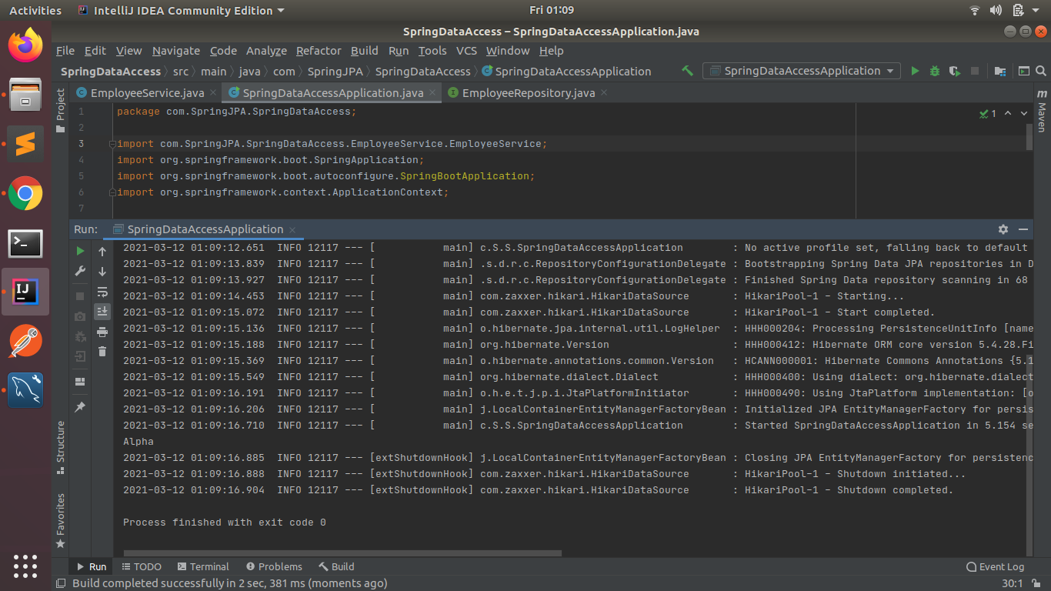

**(10) Create and use finder to find Employees Between the age of 28 to 32**

